OIO Service Oriented Infrastructure

RASP Library for .Net v. 1.1
Release Notes
Contents
1 Introduction 3
2 Release Content 3
3 What is New? 3
4 System Requirements 4
5 Licenses 4
6 Installation 4
7 Compatibility 5
8 Known Issues 5
9 Bug Fixes 5

Introduction
The OIOSI RASP Library for .Net is a .Net based toolkit for implementation of RASP business applications.

This distribution is version 1.1.

The distribution is part of the OIOSI work for exchanging business documents in a secure and reliable way using the internet. See http://www.oio.dk/arkitektur/soa/infrastruktur for more information.

The framework can be downloaded from http://www.softwareborsen.dk/projekter/softwarecenter/serviceorienteret-infrastruktur/rasp-library-for.net/releases/1.0

Release Content
This release comprises the following deliverables:

- RaspClientSource – Main Visual studio 2005 solution
- RaspClientTests– Visual studio 2005 solution with test applications

Documentation:

- OIOSI RASP Library for .Net 1.1 Installation Guide.doc
- OIOSI RASP Library for .Net 1.1 Release Notes.doc – this document
- OIOSI RASP Library for .Net 1.1 Overview.doc
- OIOSI RASP Library for .Net 1.1 API Documentation.chm

For testing (as sub components of the RaspClientTests solution file):

- dk.gov.oiosi.test.request – Sending test project
- dk.gov.oiosi.test.testMailService – Receiving test project
- dk.gov.oiosi.test.extendedRequest – Uddi, ldap and ocsp test project
- dk.gov.oiosi.test.nunit.library – Nunit test project
- dk.gov.oiosi.test.nunit.interop – Nunit interoperability test projet

What is New?
The following features are new or have changed since RC1p3:

Non-breaking changes
- Schematron caching
- Bug ……
Breaking changes

- The Address Resolving Service (ARS) architecture has been improved and will now support primary, secondary, tertiary UDDI lookups including failover UDDI to each one. Used in the NemHandel context the configuration can be setup as showed below, where the primary are the master UDDI and the secondary are the public VANS gateway.
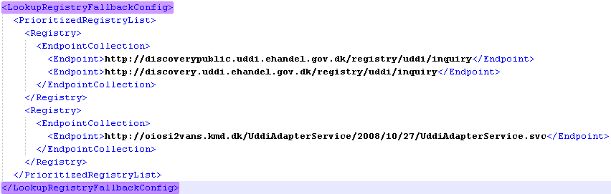
It is now possible to setup a third alternative, which could be a registry publishing endpoints for a commercial gateway.

- The OCSP entry in the configuration file has been replaced by a more generic implementation for validation certificates. The library includes a demo implementation which uses revocation lists instead of OCSP lookups. It’s recommended to use this, if the library shall send a large number of documents.

System Requirements
See “OIOSI RASP Library for .Net Installation Guide.doc”

Licenses
Some of the source code is licensed under the Mozilla Public License Version 1.1. The used license is stated below.
Please check each source file for a license declaration as some source code is licensed on other terms.

/*

* The contents of this file are subject to the Mozilla Public
* License Version 1.1 (the "License"); you may not use this
* file except in compliance with the License. You may obtain
* a copy of the License at http://www.mozilla.org/MPL/
*
* Software distributed under the License is distributed on an
* "AS IS" basis, WITHOUT WARRANTY OF ANY KIND, either express
* or implied. See the License for the specific language governing
* rights and limitations under the License.
*
*
* The Original Code is .NET RASP toolkit.
*
* The Initial Developer of the Original Code is Accenture and Avanade.
* Portions created by Accenture and Avanade are Copyright (C) 2007
* Danish National IT and Telecom Agency (http://www.itst.dk).
* All Rights Reserved.
*
* Contributor(s):
* Gert Sylvest (gerts@avanade.com)
* Patrik Johansson (p.johansson@accenture.com)
* Michael Nielsen (michaelni@avanade.com)
* Dennis Søgaard (dennis.j.sogaard@accenture.com)
* Ramzi Fadel (ramzif@avanade.com)
* Jesper Jensen (jesperj@avanade.com)
* Mikkel Hippe Brun (mhb@itst.dk)
* Finn Hartmann Jordal (fhj@itst.dk)
* Christian Lanng (chl@itst.dk)
*
*/

The Lesnikowski mail.dll library is a commercial library that ITST has bought a product license for. You may use the library, but not redistribute it. If you want to redistribute an application built with the RASP library, you may either buy a license for the existing mail library or substitute it with another by implementing the RASP mail provider interfaces.

The NUnit distributed is not a product of ITST. Following license is from the originator.
Portions Copyright © 2002-2007 Charlie Poole or Copyright © 2002-2004 James W. Newkirk, Michael C. Two, Alexei A. Vorontsov or Copyright © 2000-2002 Philip A. Craig

Installation

See “OIOSI RASP Library for .Net Installation Guide.doc”

Compatibility

No compatibility issues.

Known Issues

- Calling Abort() on the request may occasionally crash if one tries to update configuration or shut down the application during sending. [as reported: http://softwareborsen.dk/projekter/softwarecenter/serviceorienteret-infrastruktur/rasp-reference-client/issues/22/view].
This is due to a bug in the WCF WS-RM implementation that Microsoft has recognised. [as reported: http://forums.microsoft.com/MSDN/ShowPost.aspx?PostID=2189376&SiteID=1]

Bug Fixes

For a list of reported bugs that have been fixed in this version, please refer to
http://www.softwareborsen.dk/projekter/softwarecenter/serviceorienteret-infrastruktur/rasp-library-for.net/issues

